Copyright for test papers and marking guides remains with *West Australian Test Papers.*

Test papers may only be reproduced within the purchasing school according to the advertised Conditions of Sale.

Test papers should be withdrawn after use and stored securely in the school until Wednesday 12th October 2016.



**SEMESTER TWO**

**MATHEMATICS**

**SPECIALIST**

**UNITS 3 & 4**

**2016**

**SOLUTIONS**

***Calculator−free Solutions***

1. 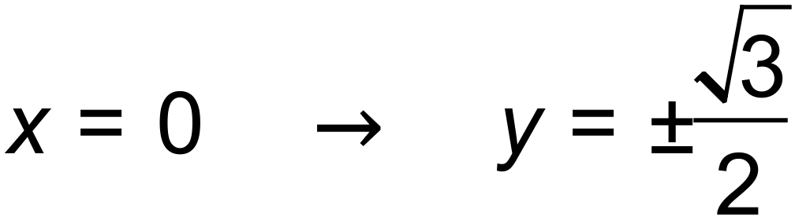 ✓

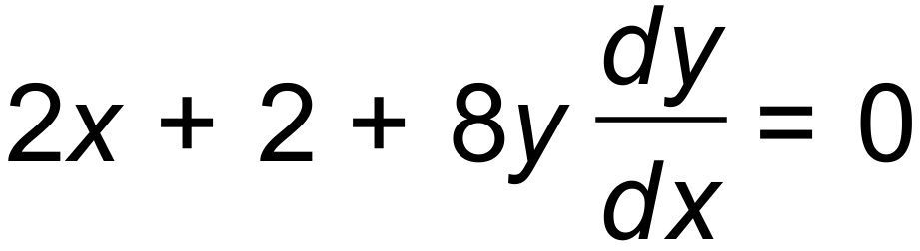 ✓✓

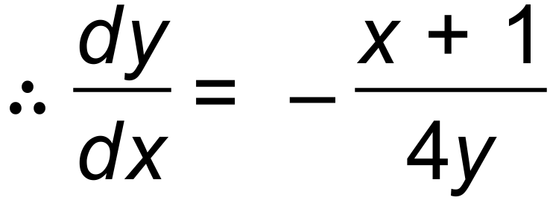

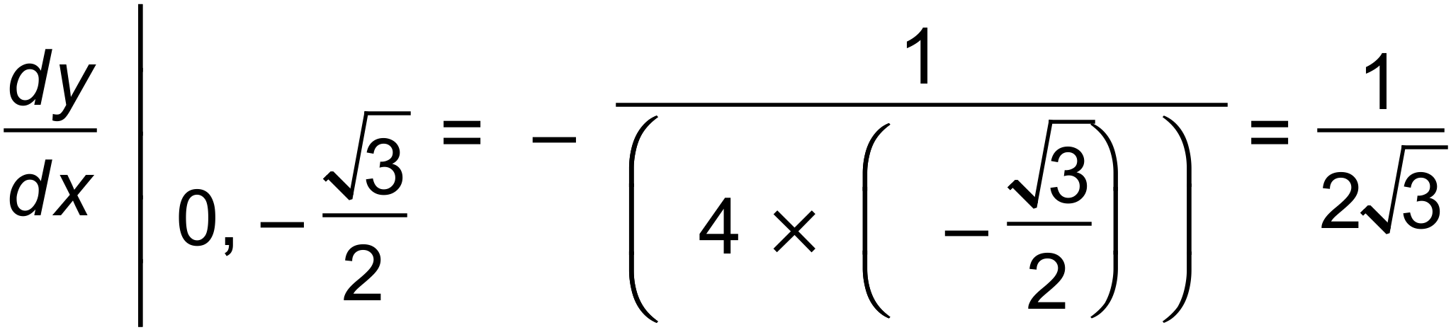 ✓

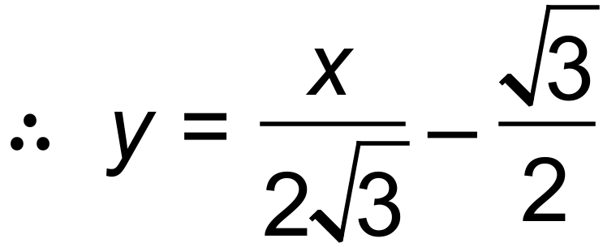 ✓ [5]

2. (a) 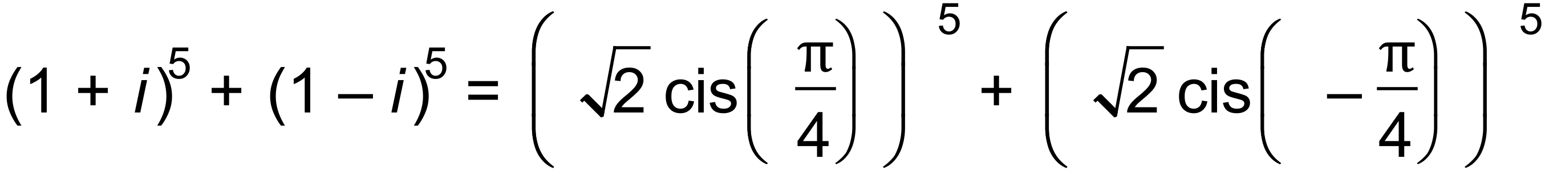 ✓

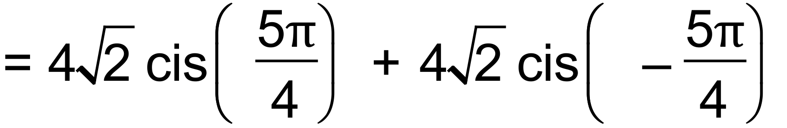 ✓

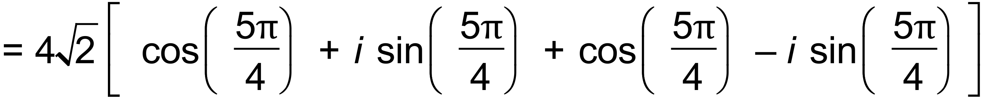 ✓

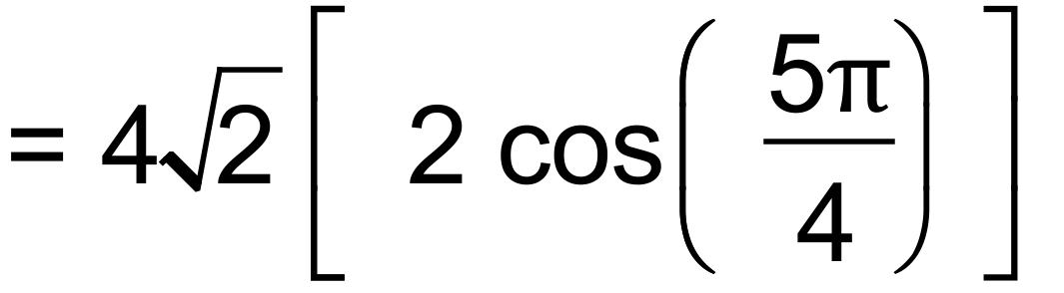

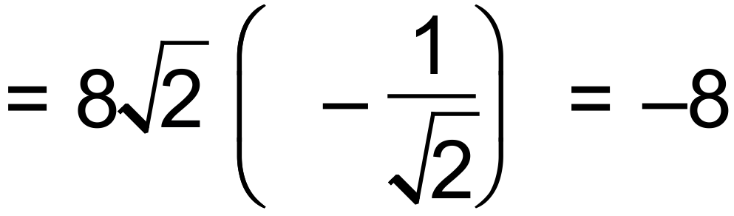 ✓✓

(b) (i) 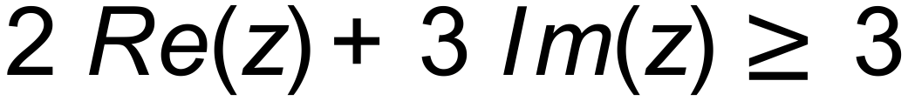 ✓✓

(ii) 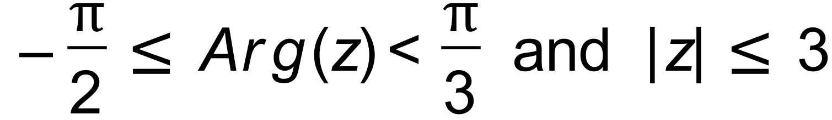 ✓✓✓ [10]

3. (a) 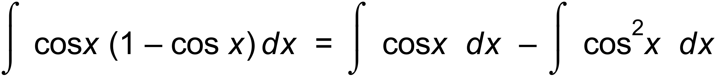

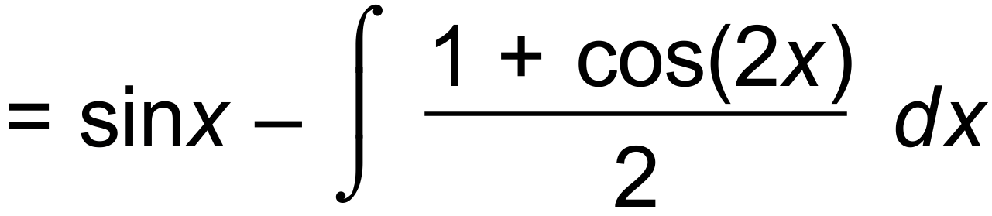 ✓✓

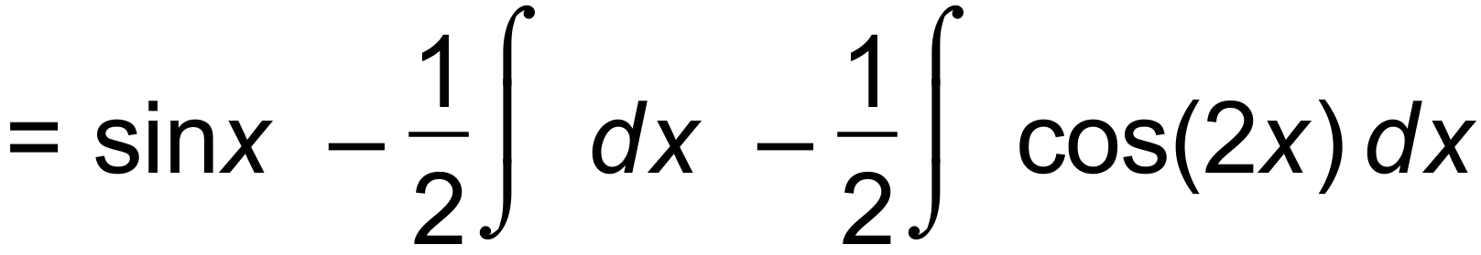

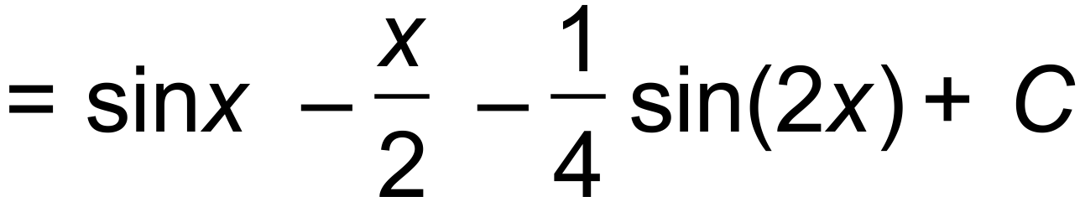 ✓✓

3. (b) Let 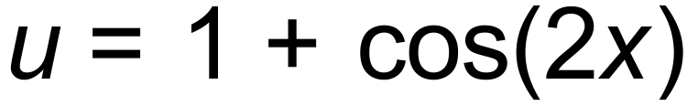 ✓

Then 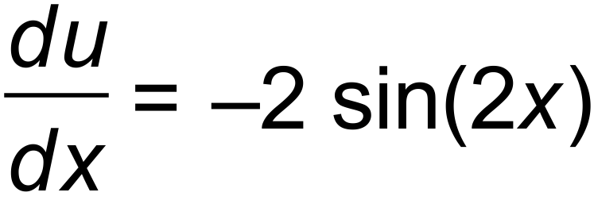 and hence 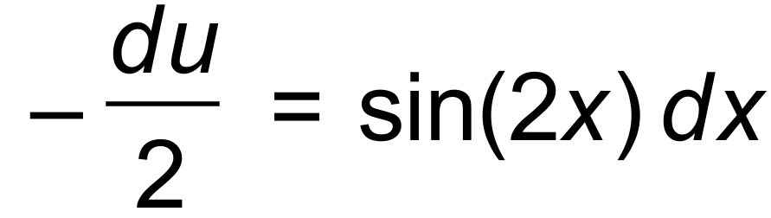 ✓

Also, 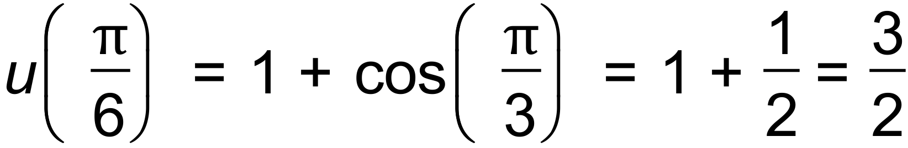

and 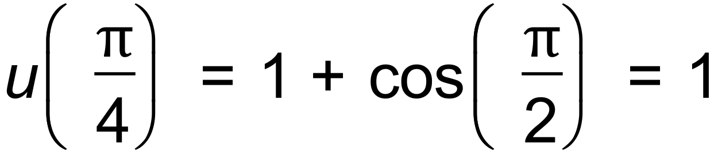 ✓

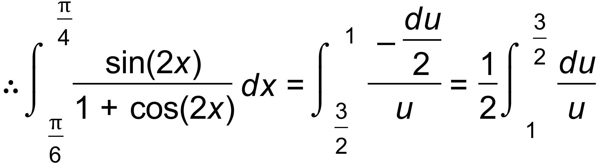 ✓

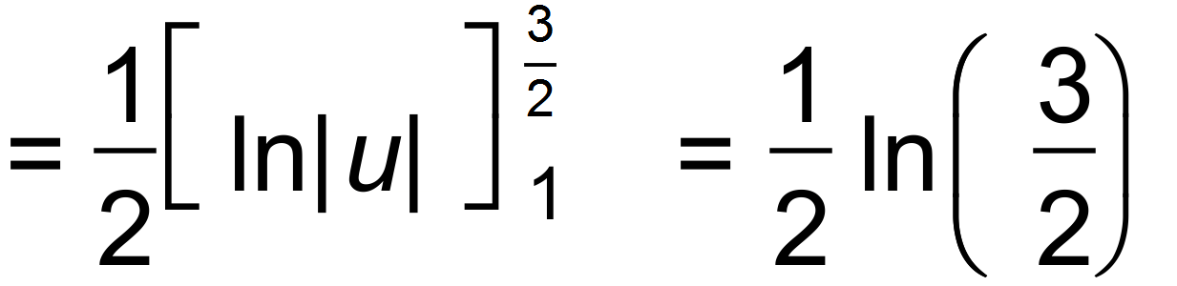 ✓ [9]

4. (a) 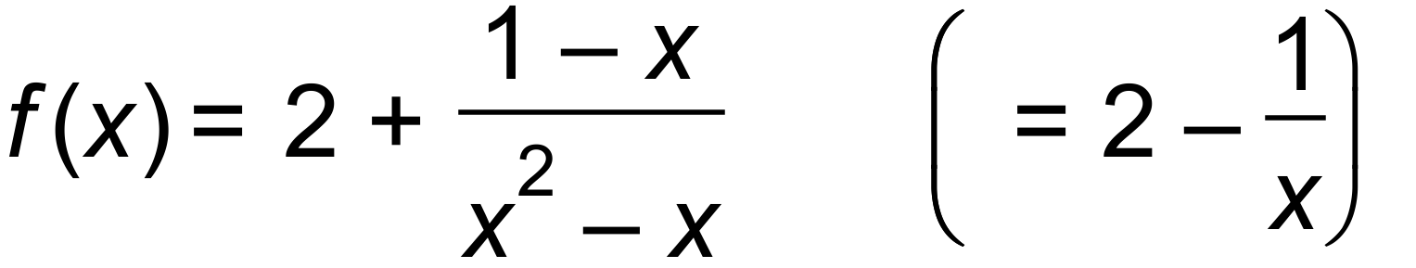 ✓✓✓

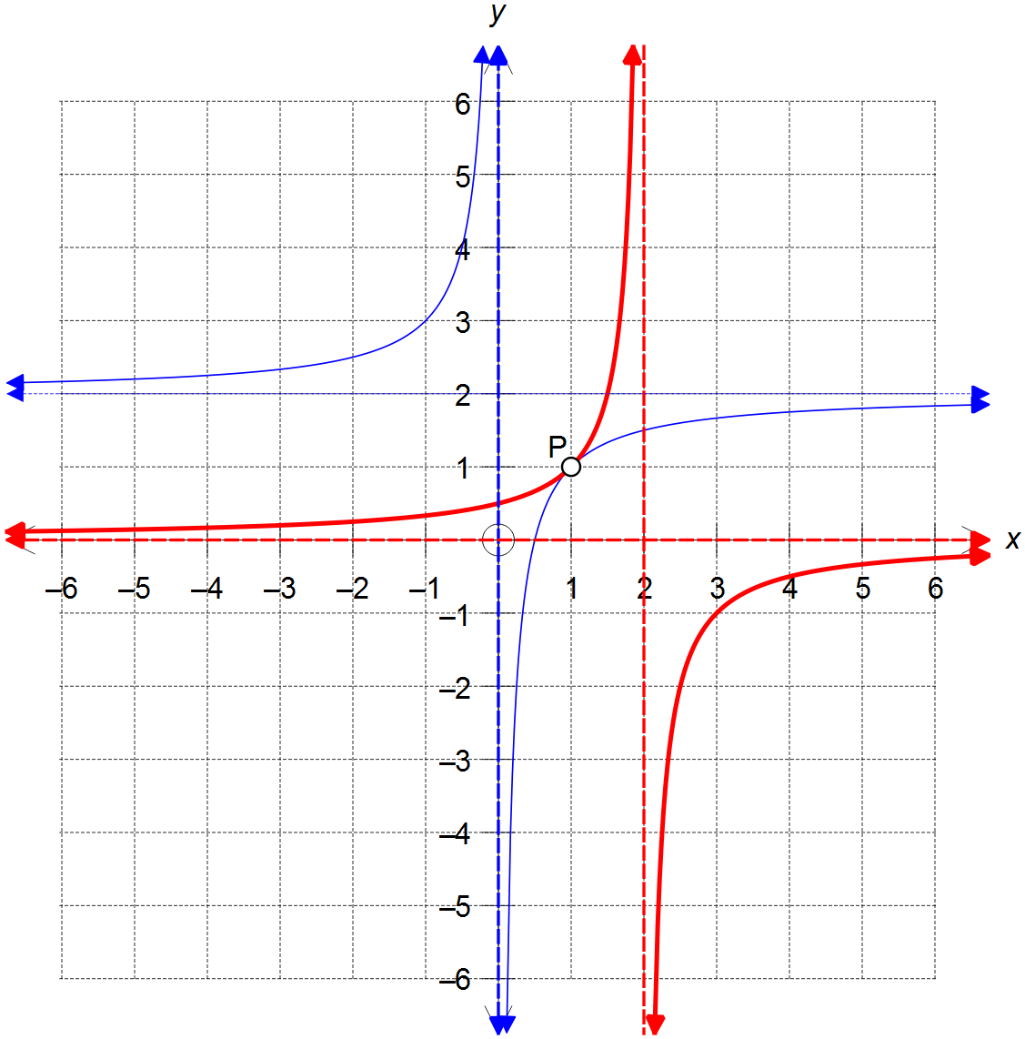

(b) (e)

(b)

✓ Reciprocal Curve

✓ Marks undefined point P

✓ Vertical asymptote at x=0

✓ Horizontal asymptote at y=2

(e) (in bold)

✓ Asymptotes x=2 and y=0

✓ Marks undefined point P

(c) Range =  ✓

(d) 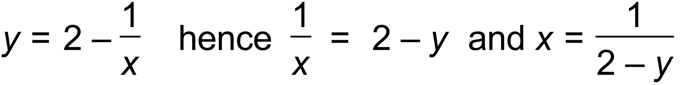 ✓

therefore 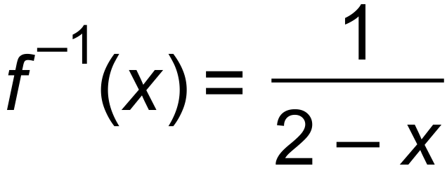 as required

domain =  ✓ [12]

5. (a) 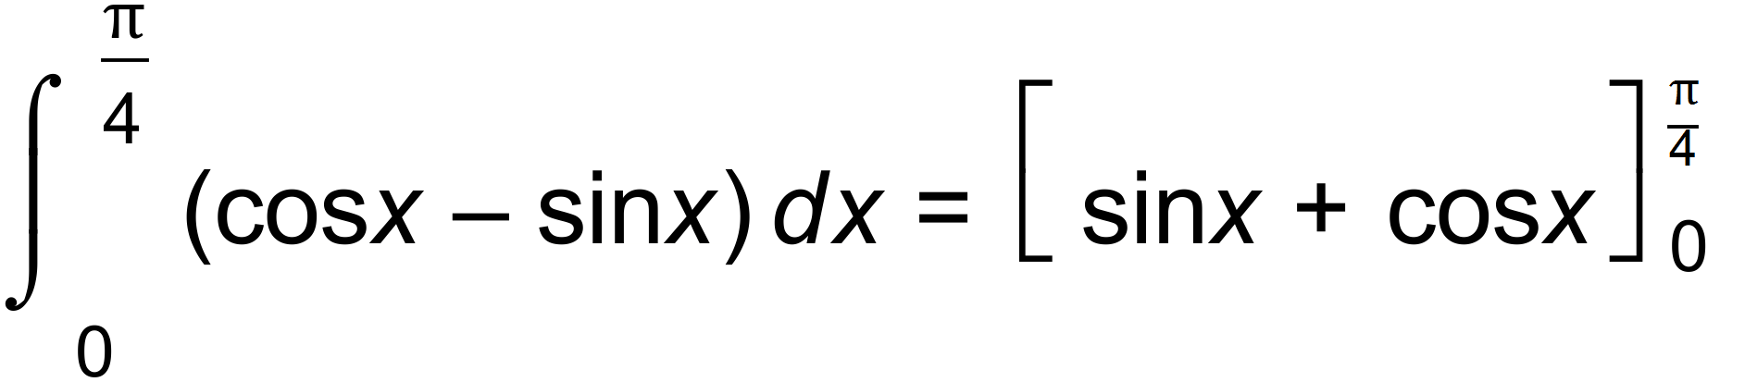 ✓

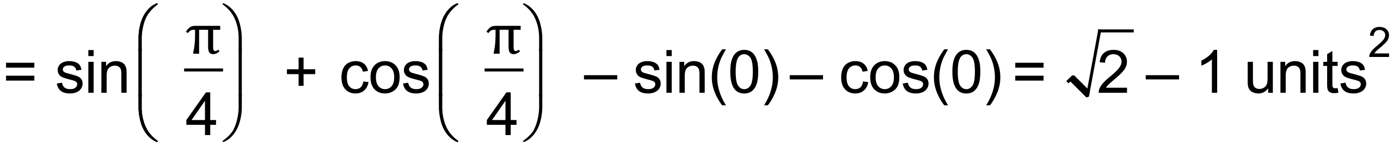 ✓

(b) 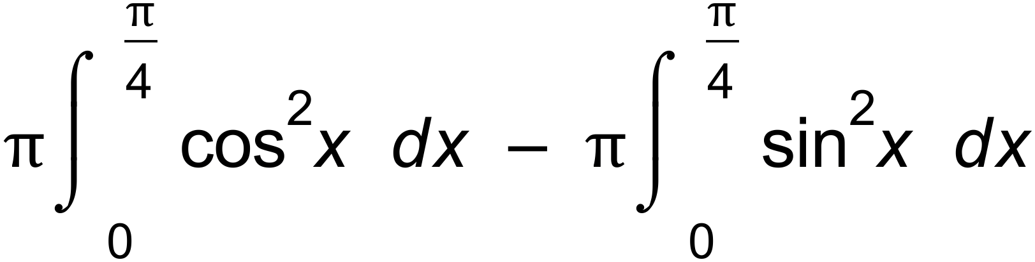 ✓

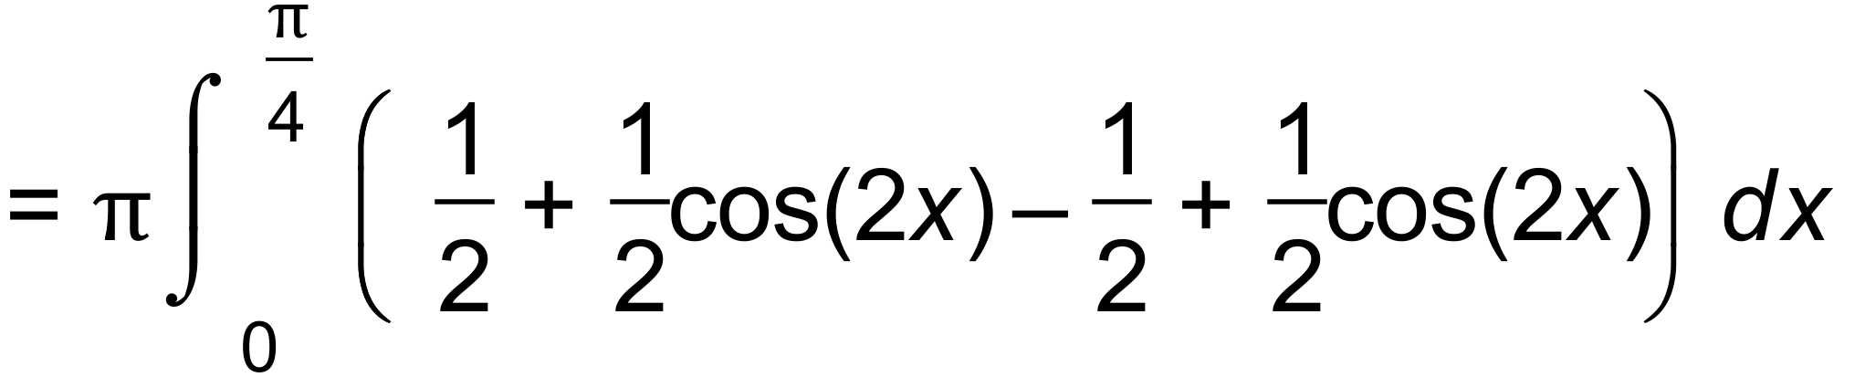 ✓

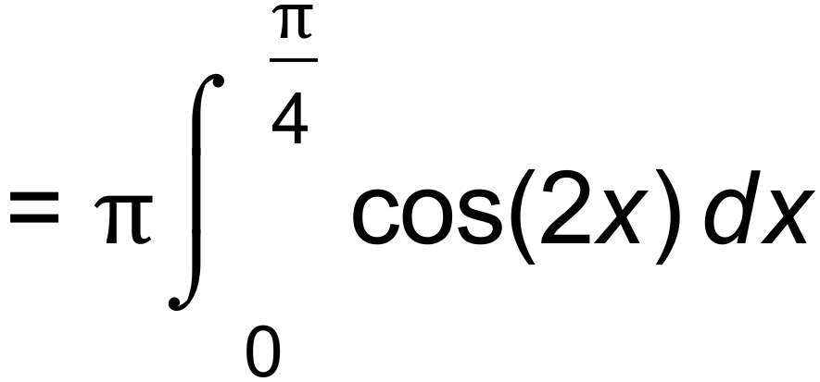 ✓

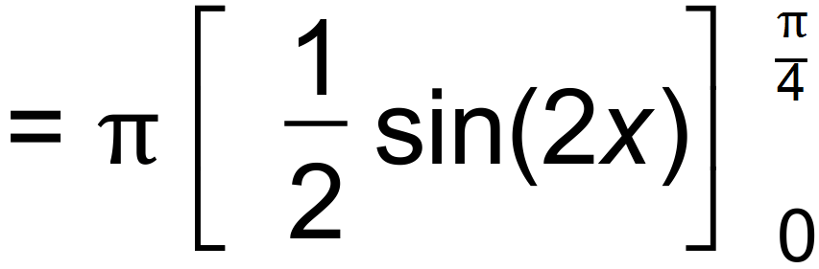 ✓

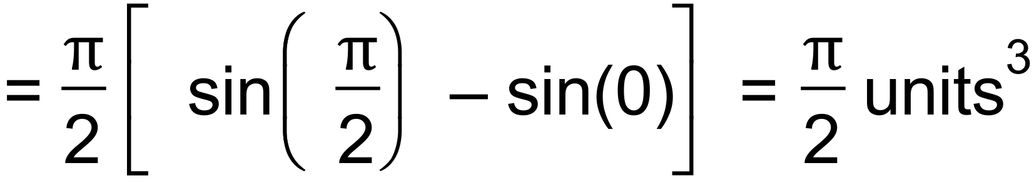 ✓ [7]

6. (a) 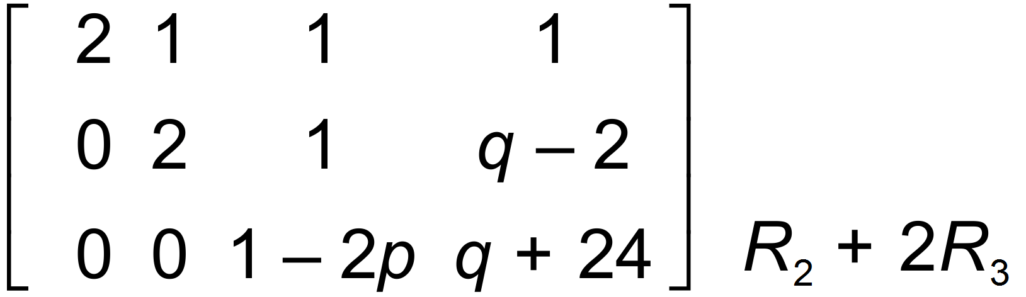 ✓✓

(b) 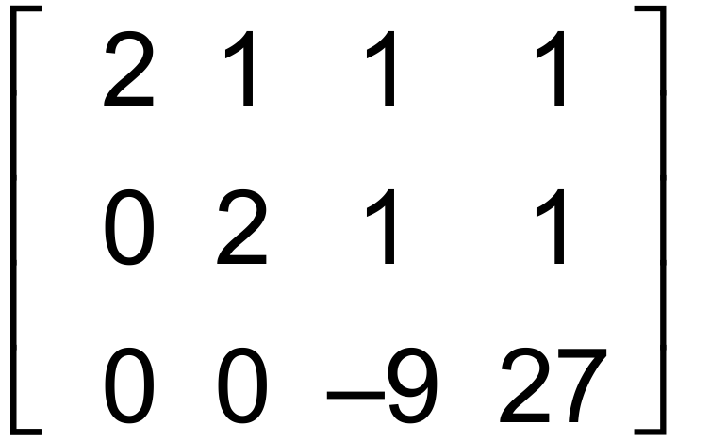

 ✓

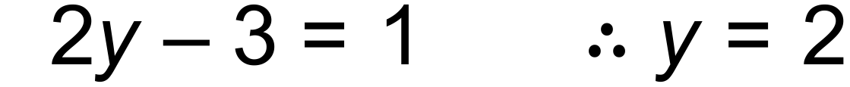 ✓

 ✓

(c) (i) 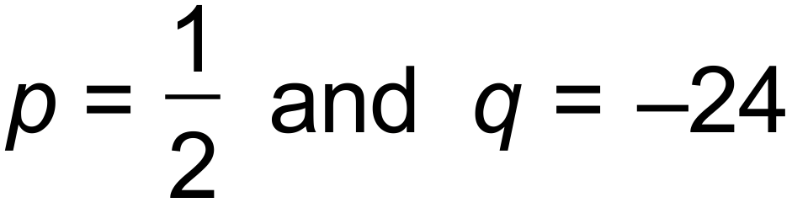 ✓

(ii) 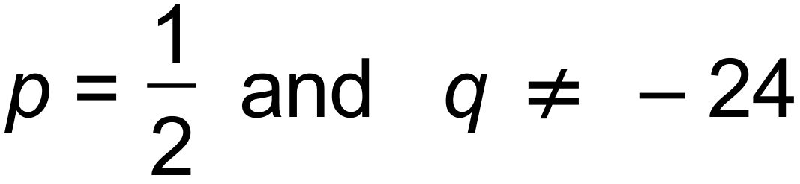 ✓ [7]

***Calculator−assumed Solutions***

7. (a)  ✓✓

(b)  ✓

(c) CAS → 

 ✓✓ [5]

8. (a)  ✓

Domain =  ✓

Range =  ✓

 ✓

Domain =  ✓

Range =  ✓

(b) 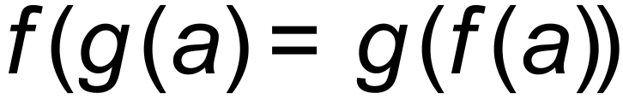 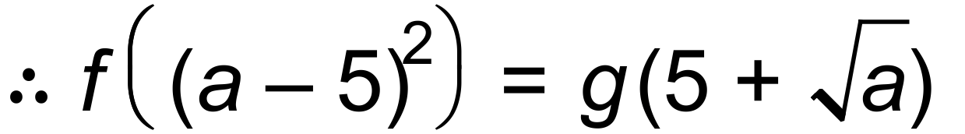

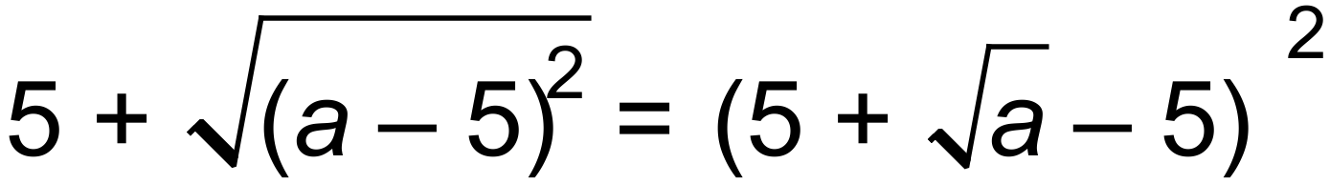 ✓

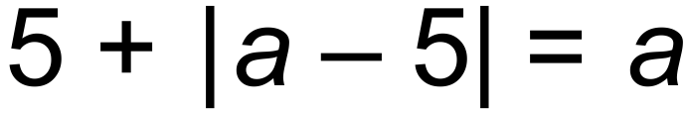

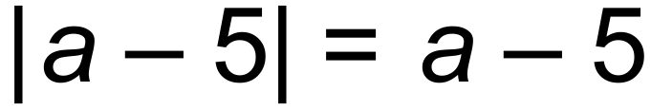

 ✓

(c) 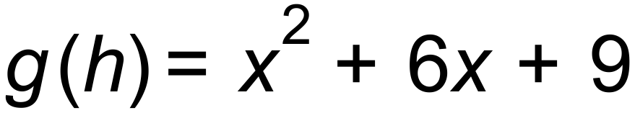

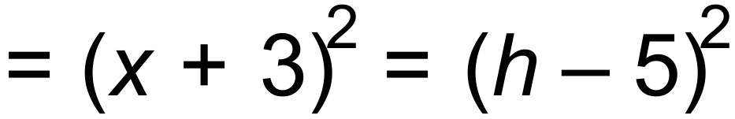 ✓

 hence ✓



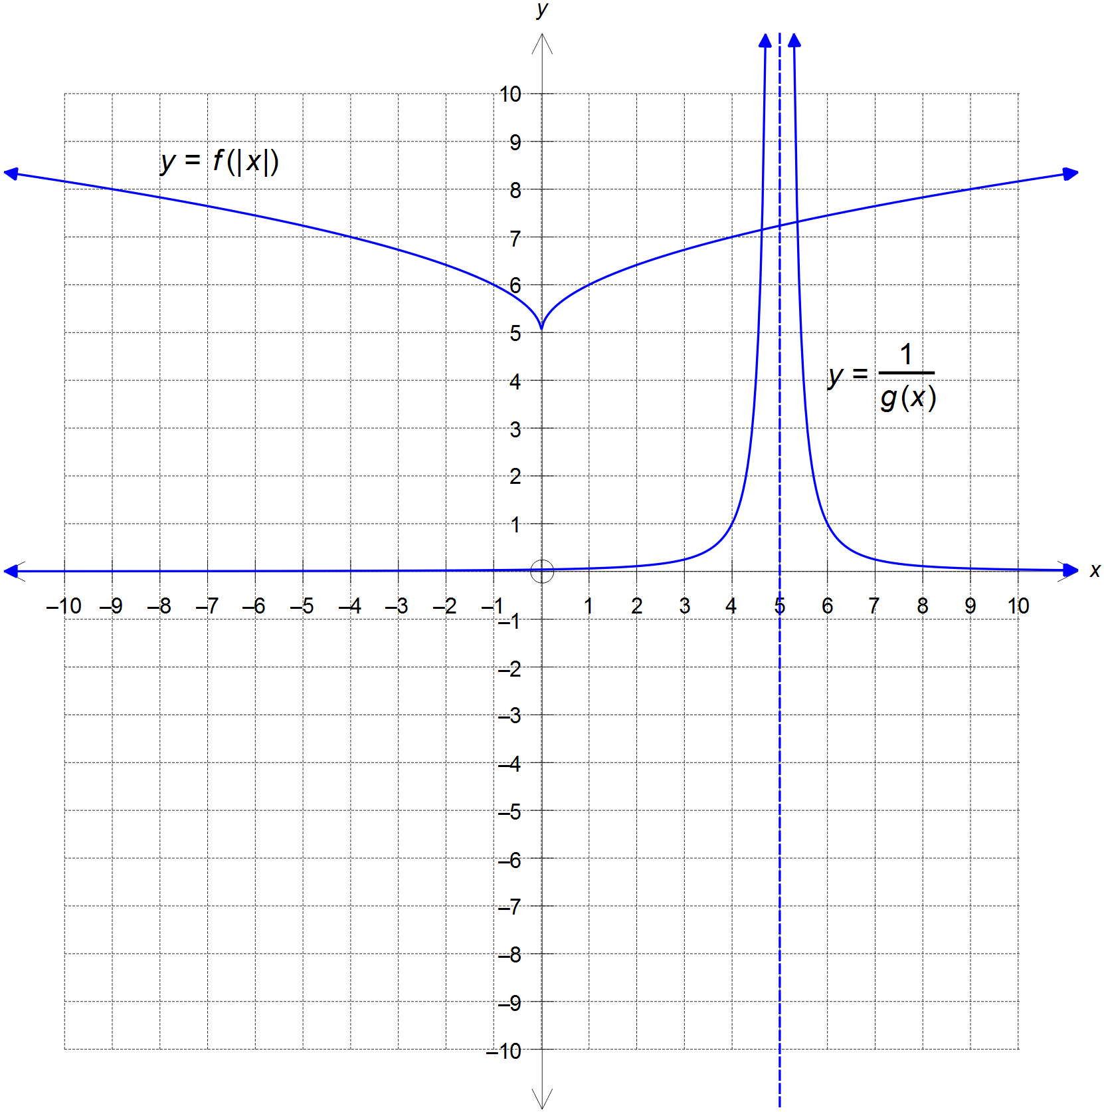

(d)

✓ point of reflection

✓ mirror shape on 2nd quadrant

✓ Vertical asymptote at x=5

✓ Horizontal asymptote at y=0

✓ Shape and accuracy

[15]

9. (a) 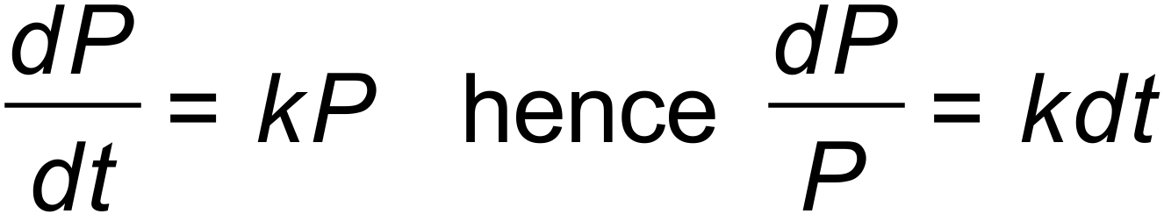

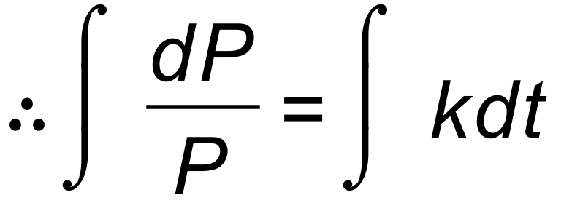 ✓

 ✓

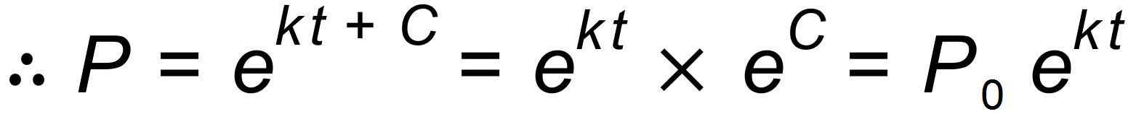 ✓

(b) (i) At , 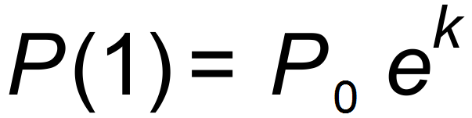 thus 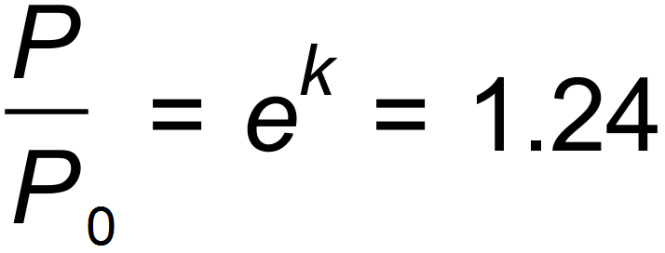 ✓

 ✓

therefore, 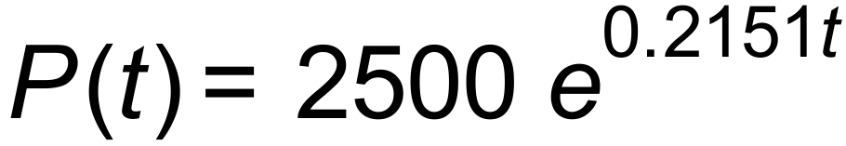

and 

~ 4280 fish ✓

(ii) 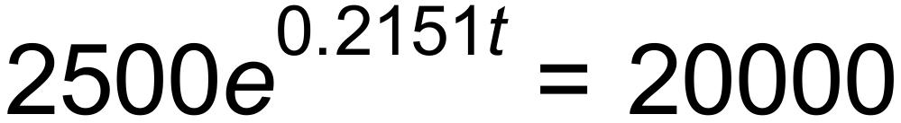 ✓

 ✓ [8]

10. (a) Point of reference is P(5, 0). From P:

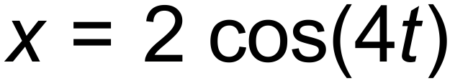

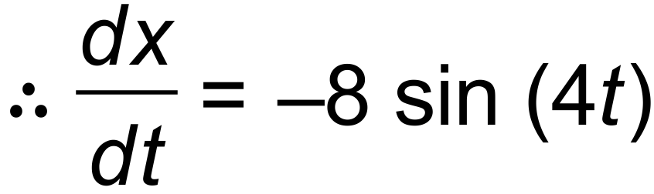 ✓

and 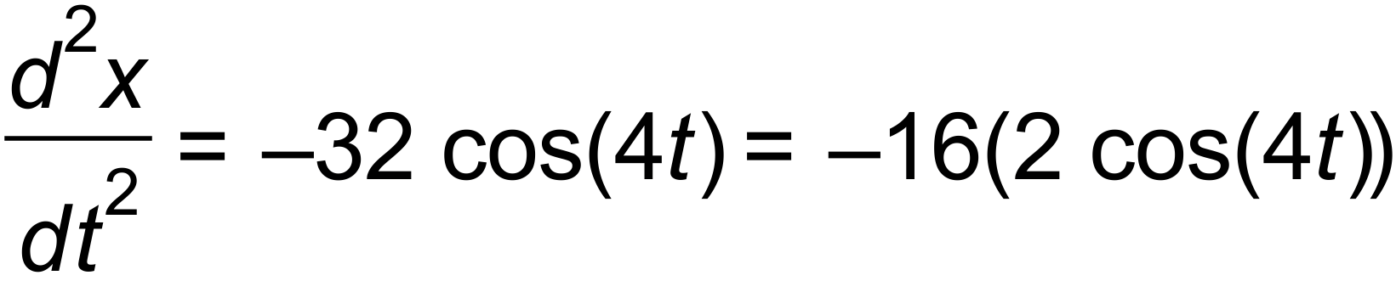 ✓

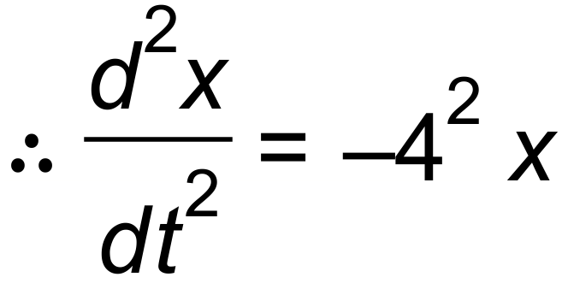 which is the condition for SHM ✓

(b) 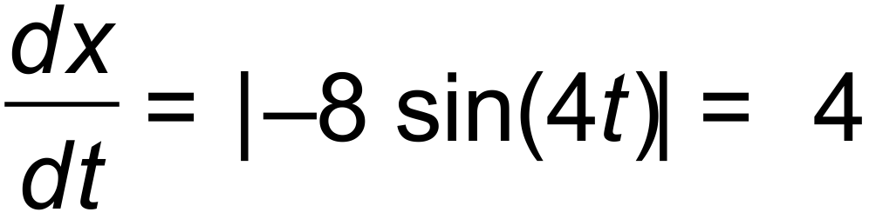

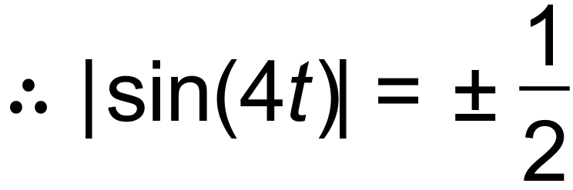 and hence 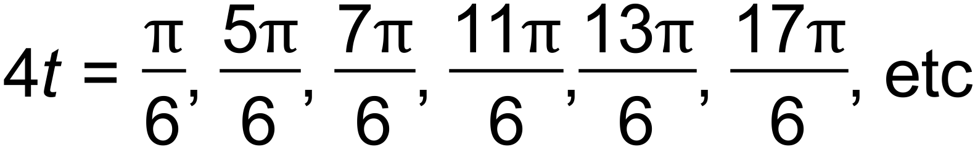 ✓

and 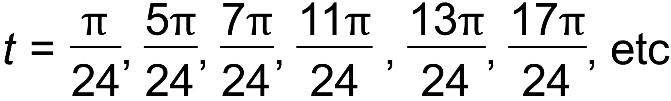

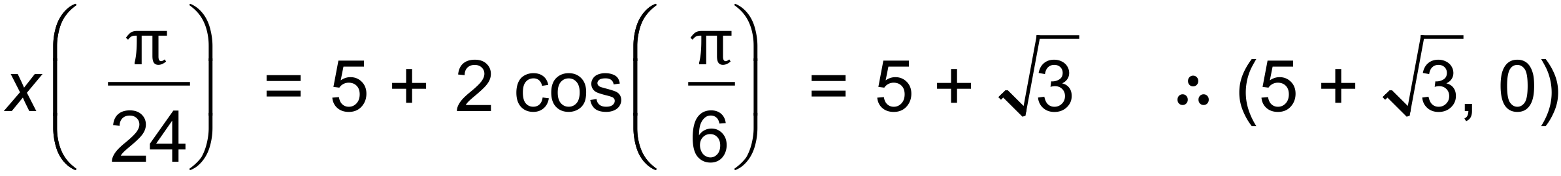 ✓

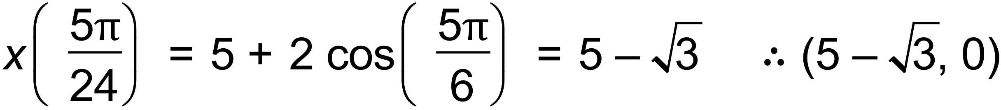 ✓

(c) 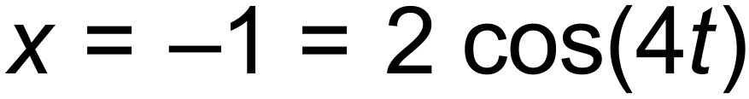

 ✓ [7]

11. (a) (i) 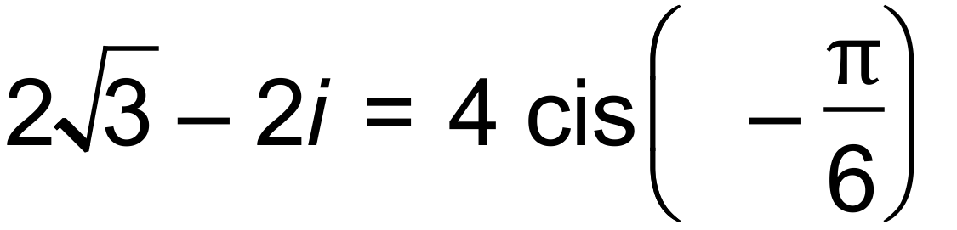 ✓

Other roots are 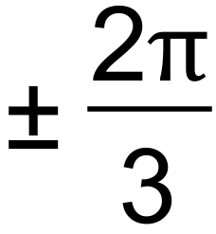 apart, hence

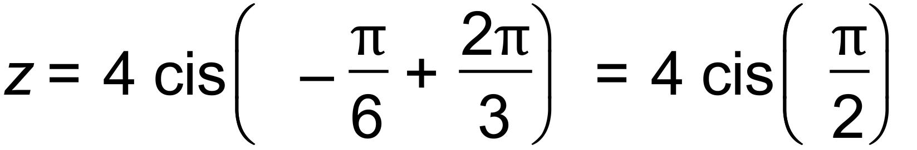 ✓

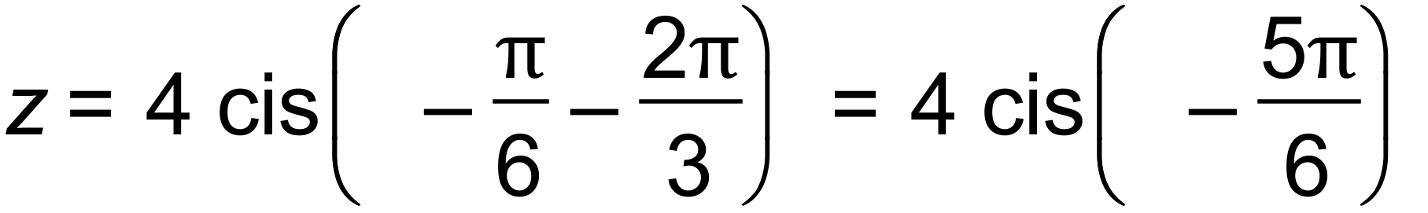 ✓

(ii) 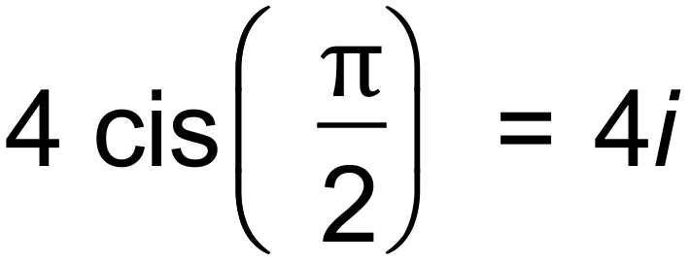 ✓

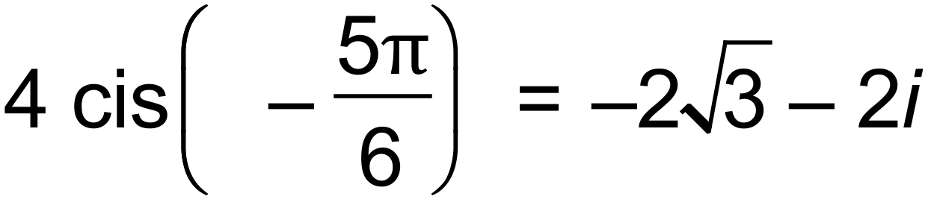 ✓

(b)

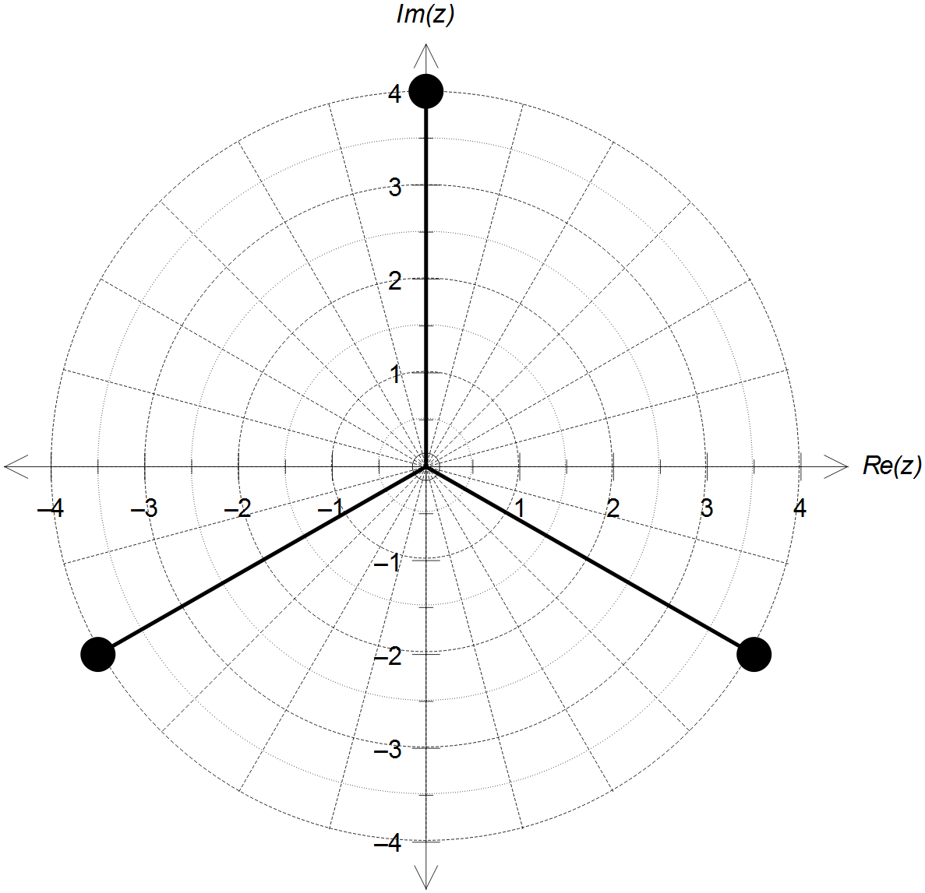

✓ Same magnitude

✓ Equally spaced 120° apart

(c)

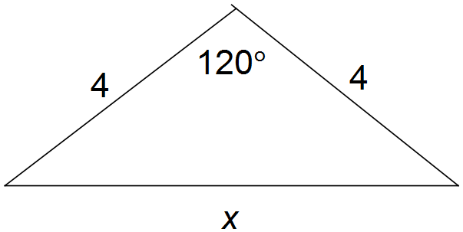

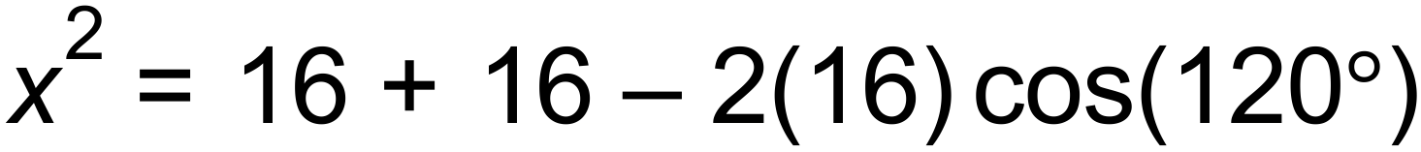 ✓

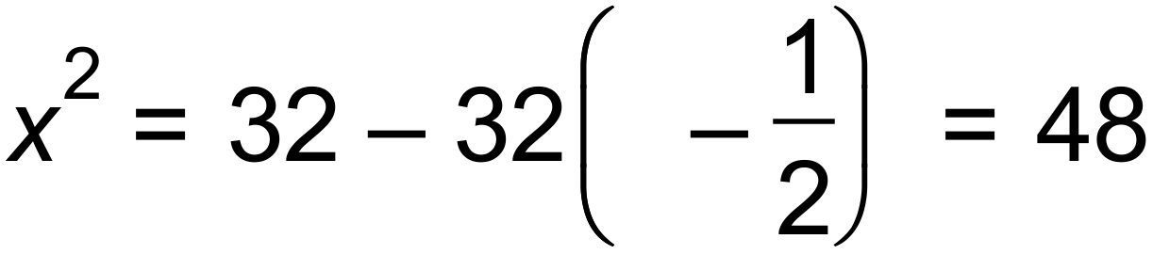

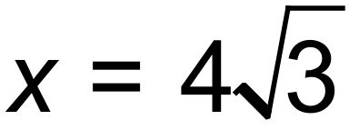 ✓

 ✓ [10]

12. (a) 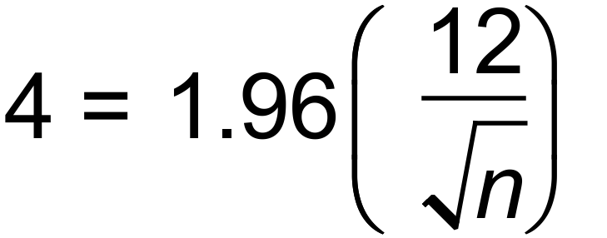 ✓✓

 i.e. 35 calculators are needed ✓

(b) 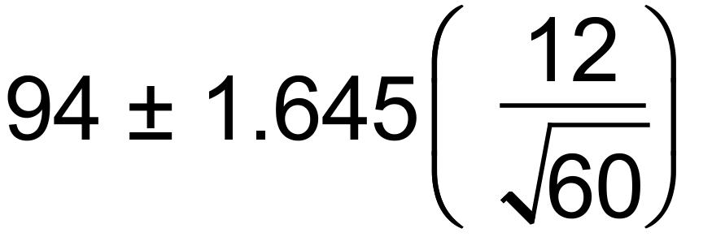 ✓✓

 ✓

(c) No, as the 90% interval does not contain the

100hr claimed. ✓✓ [8]

13. (a)

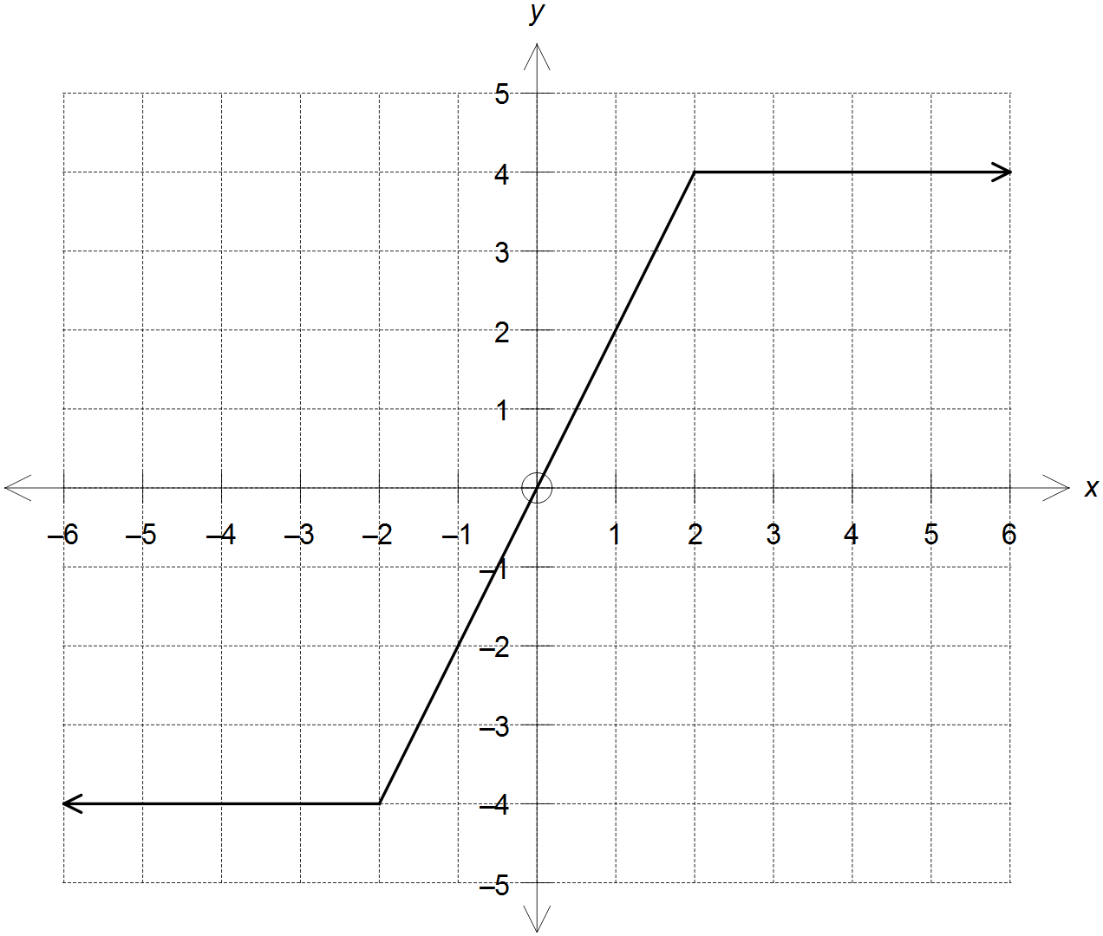

✓ line y = 2x

✓ lines y = 2 and y = –2

(b) Two possible solutions:

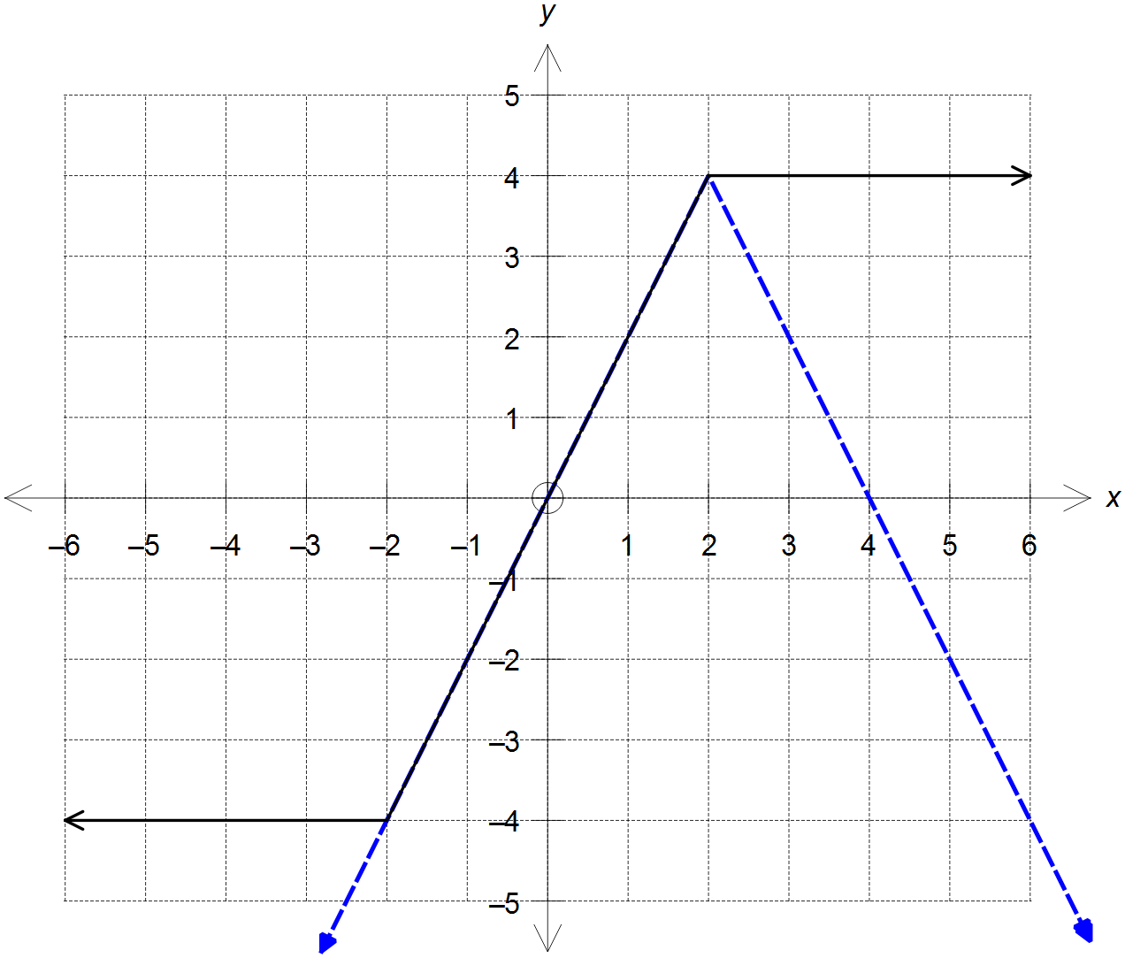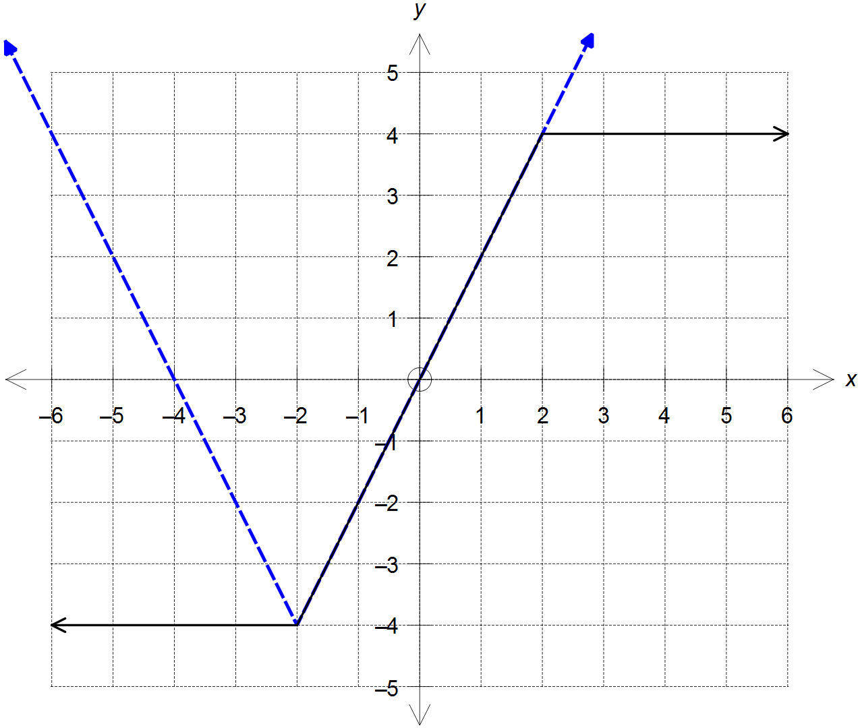

hence,  ✓✓✓

or  ✓ [6]

14. (a) 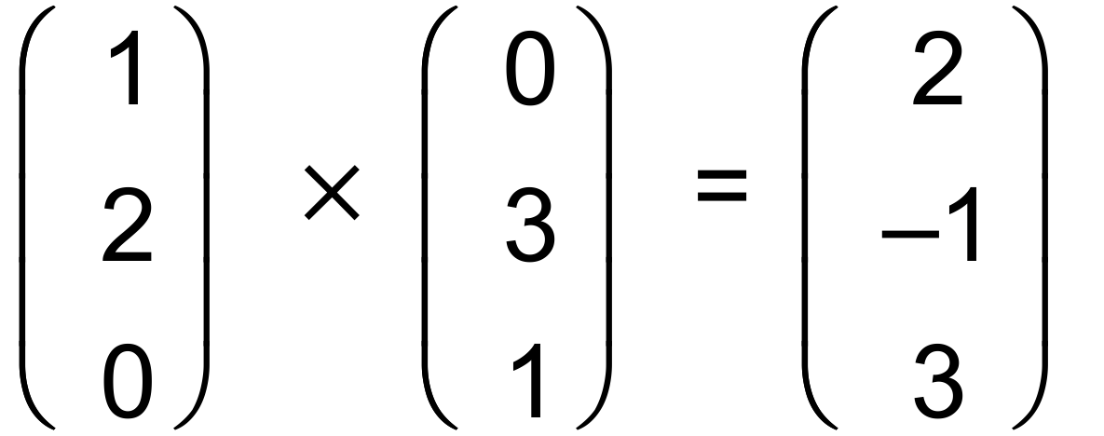 ✓

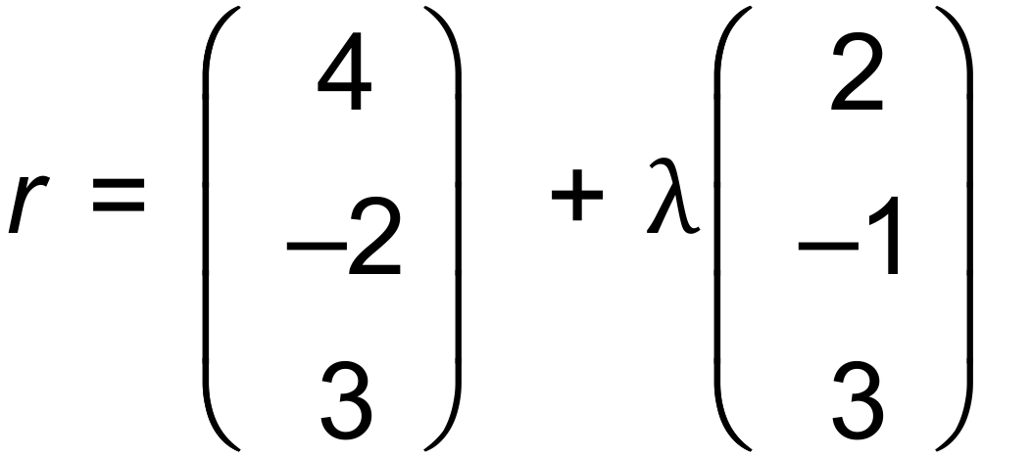 ✓

(b) 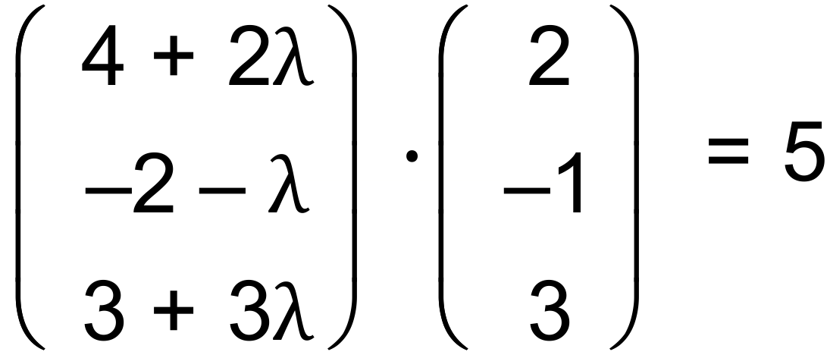 ✓

CAS →  ✓

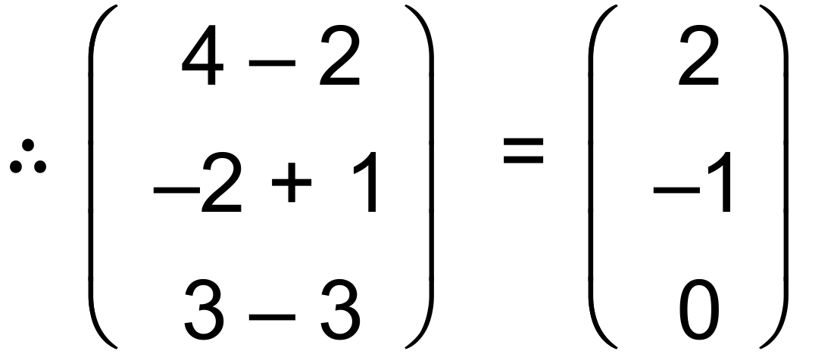 ✓

(c) 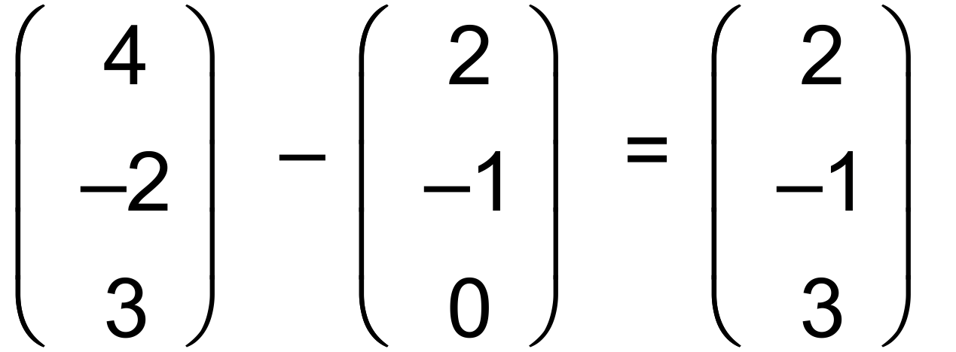 ✓

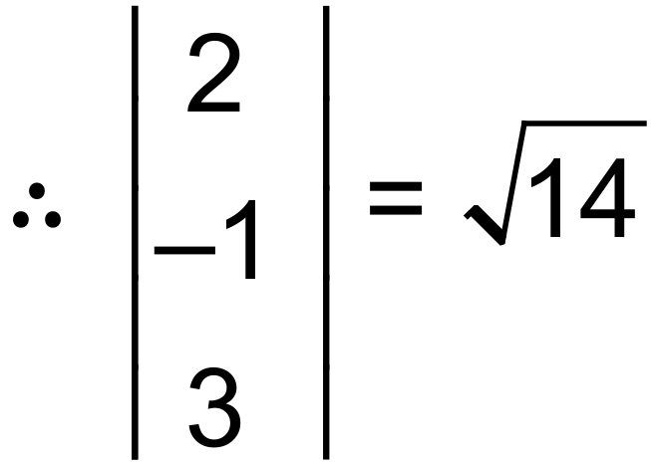 units ✓

(d) Use the normal to the xy plane and the normal to the plane  : ✓

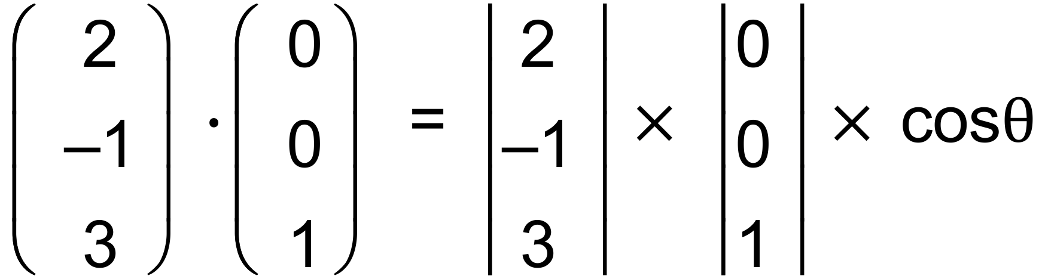 ✓

 ✓

(e) Create a line perpendicular to the plane that passes through O:

Let 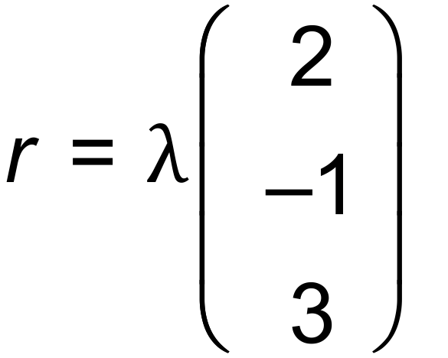

Find the point of intersection of this line and the plane:

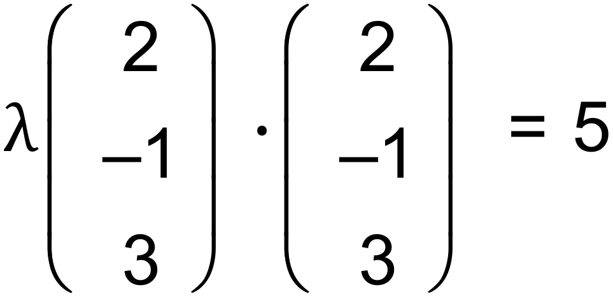 ✓

CAS → 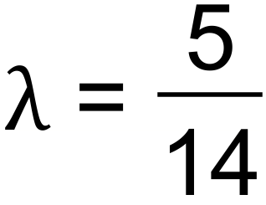 ✓

Hence, 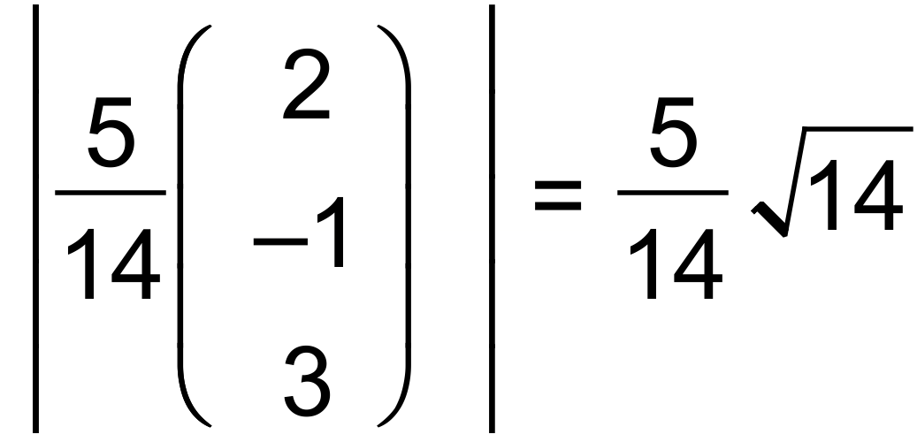 , so equation is 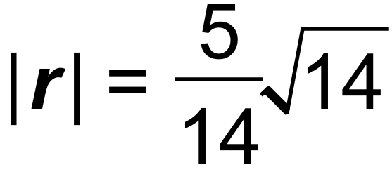 ✓

And the point of tangency is:

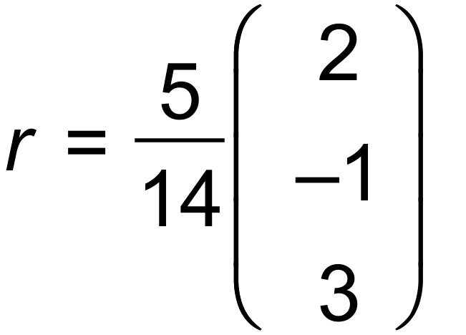 ✓ [14]

15. (a) 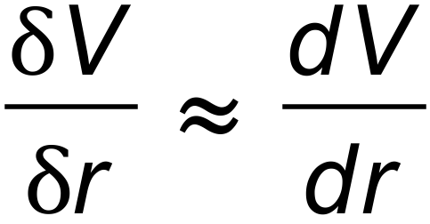

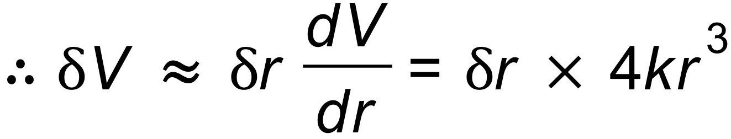 ✓

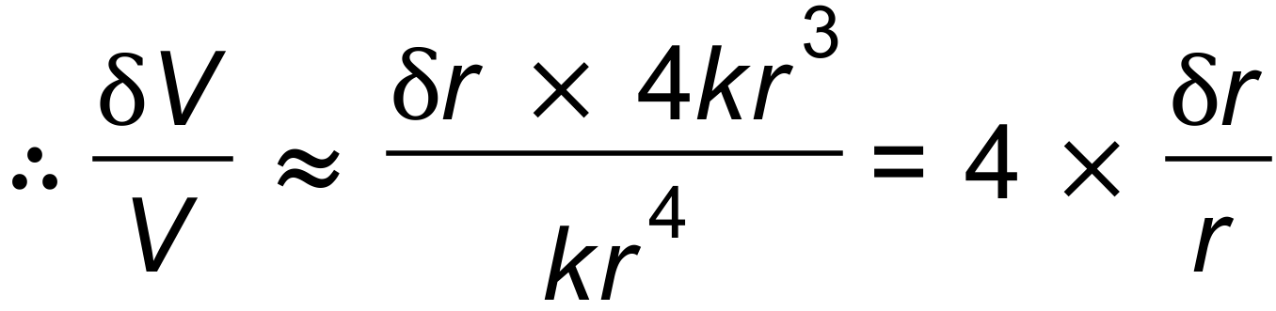 ✓

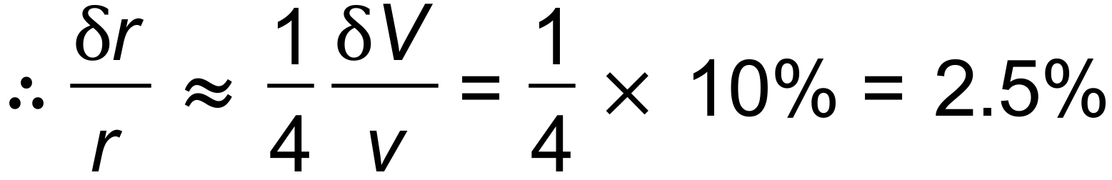 ✓

(b) rate given: 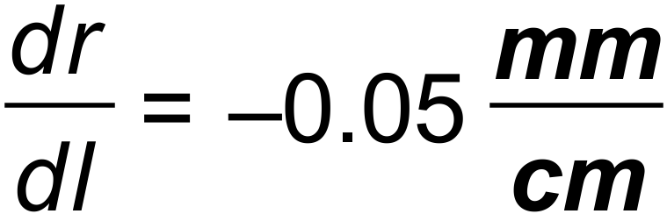

rate needed: 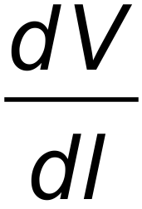

hence, 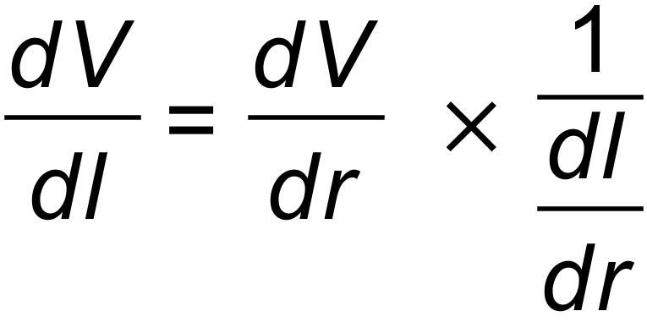 ✓

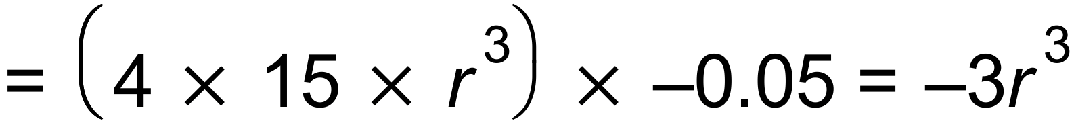 ✓

 ✓

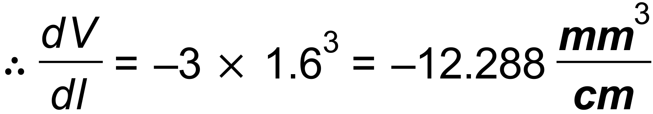 ✓ [7]

16. (a) 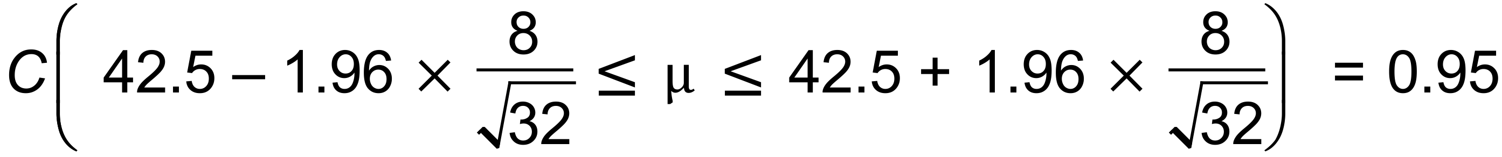 ✓

 ✓✓

The engineers can be 95% confident that the mean operating

temperature of the lithium-ion batteries is somewhere between

39.73°C and 45.27°C. ✓

(b) 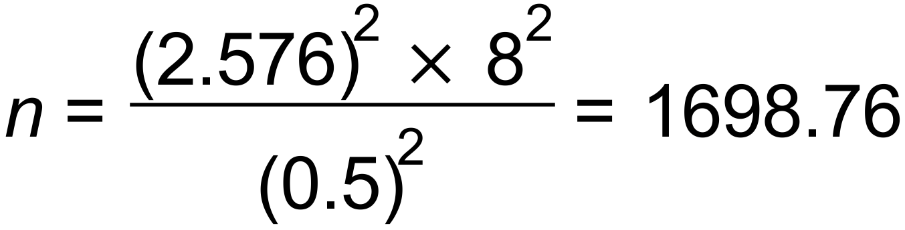 ✓✓

They will need 1699 batteries to be within 0.5°C of the

true mean. ✓ [7]

17. (a) 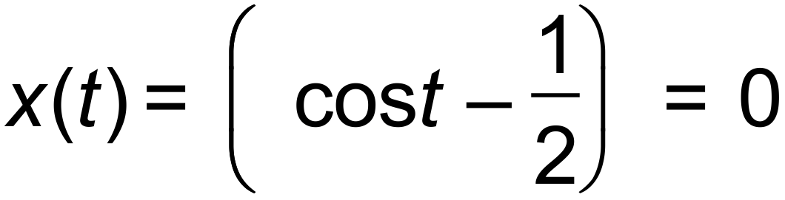

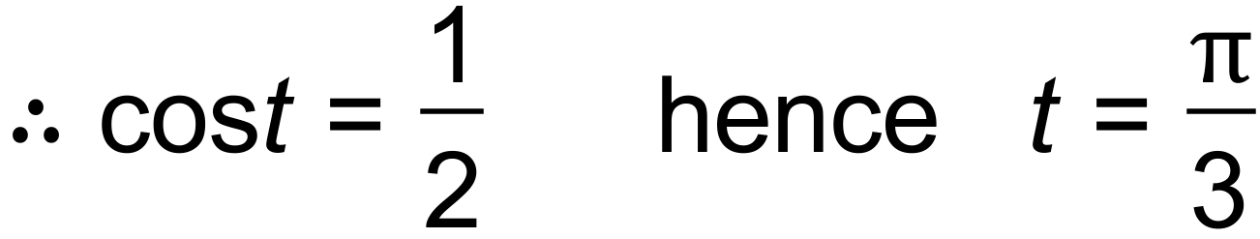 ✓

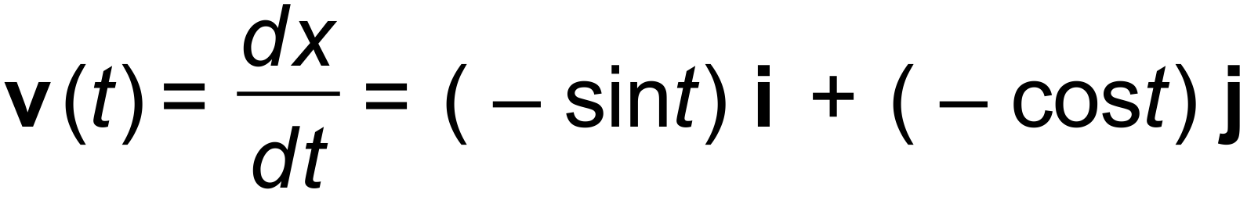 ✓

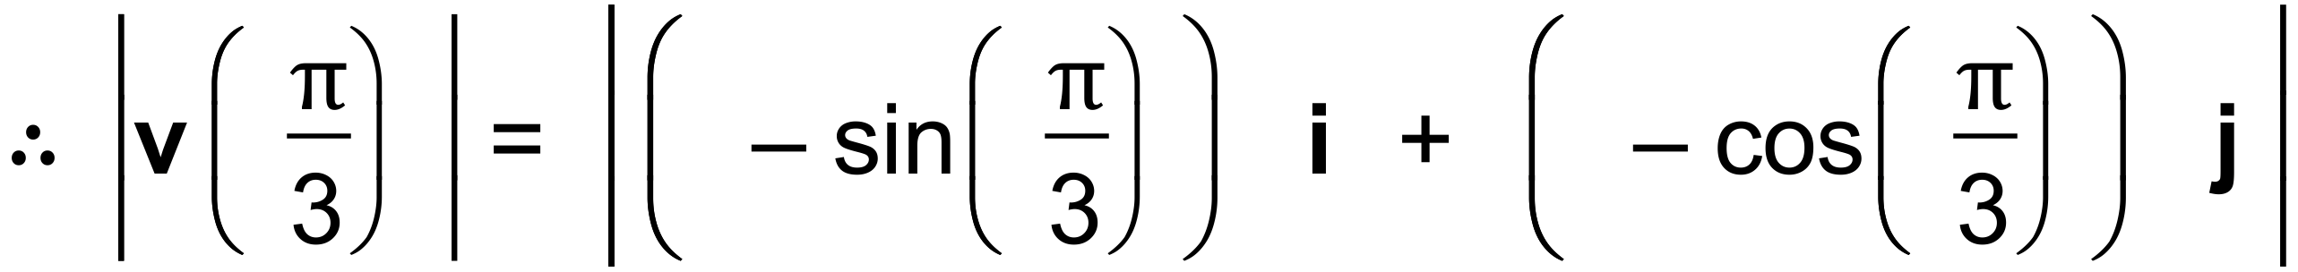 ✓

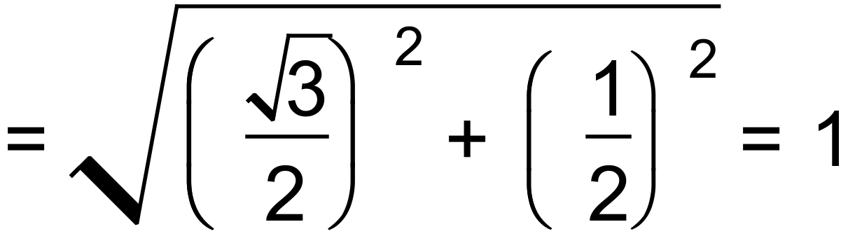 units/s ✓

(b) 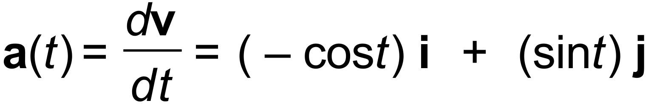 ✓

 unit/s2 ✓

(c) 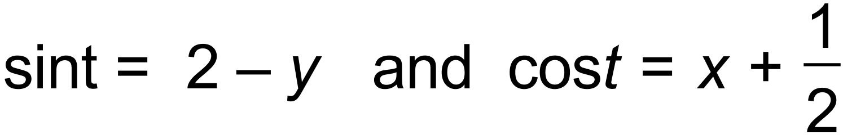

since 

then 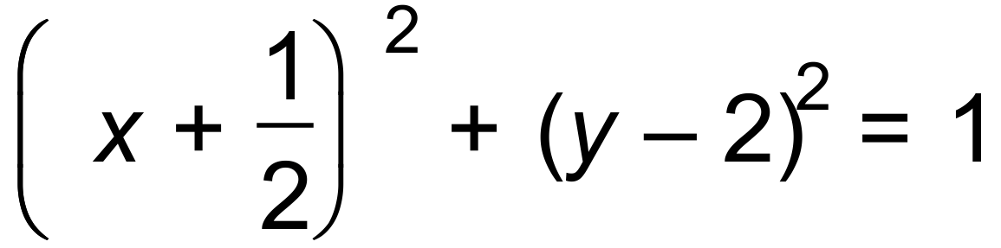 ✓

the path is a circle centred at 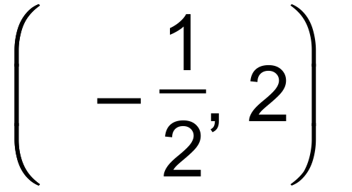 of radius = 1 unit ✓ [8]

18. (a) 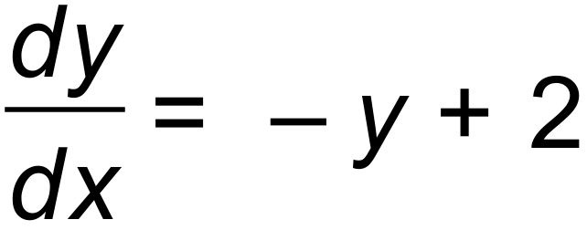 ✓✓

Reasons: (at least 1) ✓

* when 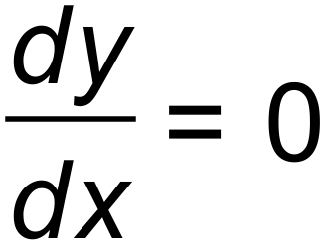 the isoclines follow the line 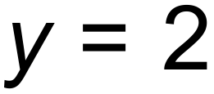
* the isoclines describe exponential solutions
* the isoclines follow exponential decay, hence “-y”

(b)

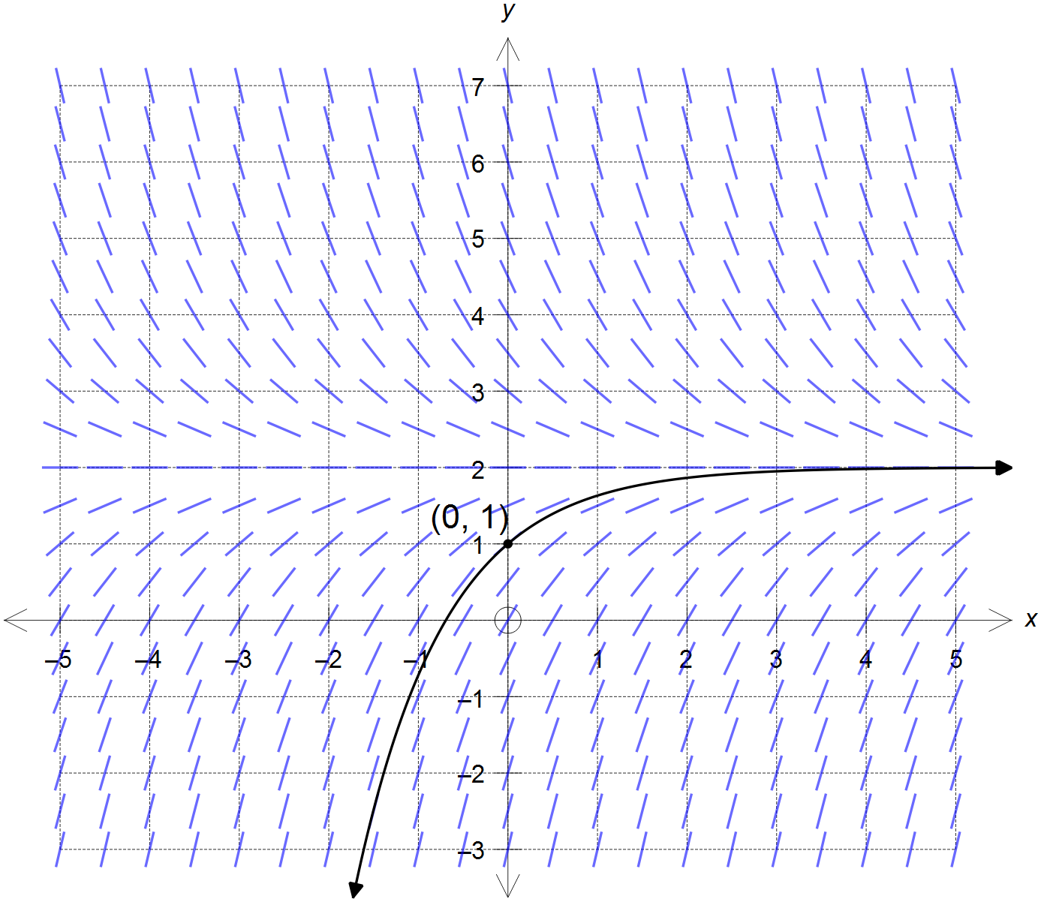

✓ exponential curve that

follows the isoclines

✓ passes through the point

(0, 1)

[5]